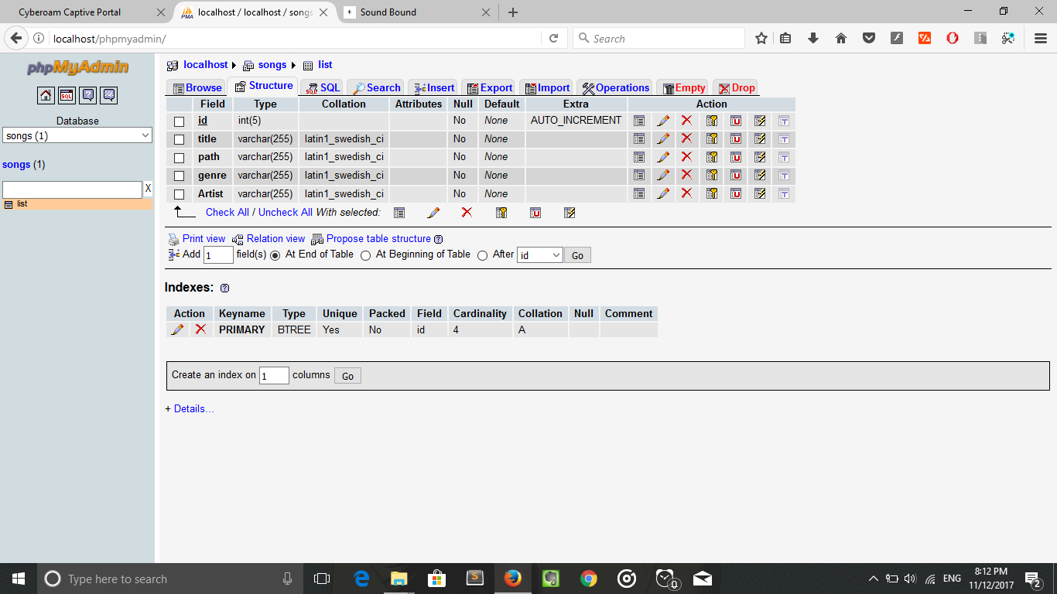

Database name : songs

Table name : list

Columns in the table: id (primary key and autoincrement), title, path, genre, Artist